Bulletin Information

Date Excavation was completed | 4th August 2017
Confirm excavation completion date | 4th August 2017
Year | 2017
County | Kildare
Author | David Bayley
Author’s Address | IAC Ltd, Unit G1 Network Enterprise Park, Kilcoole, Co. Wicklow
Site No | Automatically generated by website
Site Name | Barrettstown 1
Site Type | Cereal drying kiln and curvilinear feature
ITM Coordinates | 688045/723725
Latitude & Longitude | Converted once submitted to website
Sites & Monuments Record No. | n/a
Excavation License No. | E004878
Description | Stage (iii) archaeological excavation at Barretstown 1 (Registration No.: E004878, Ministerial Direction No.: A073), was carried out in advance of the M7 Naas–Newbridge Bypass Upgrade and the M7 Osberstown Interchange and R407 Sallins Bypass Scheme, Co. Kildare. It was discovered during Stage (i) archaeological testing undertaken by Irish Archaeological Consultancy (IAC) Ltd and was further assessed during Stage (ii) Pre-Excavation.  Barretstown 1 consisted of a cereal-drying kiln with a fire-bowl at either end of an elongated stone flue defined by a rough setting of stones. The kiln was later cut by a curvilinear feature which continued outside the Lands Made Available.
Image | 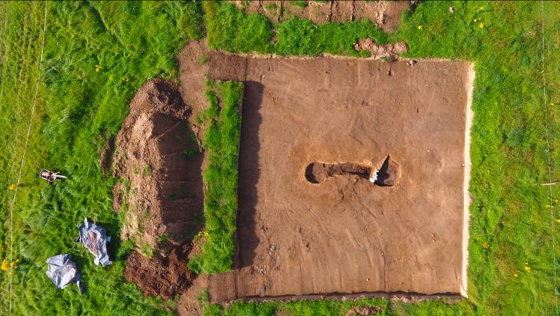  Barrettstown 1, mid-excavation, aerial photograph.

