Bulletin Information

Date Excavation was completed | 25/04/2017
Confirm excavation completion date | 25/04/2017
Year | 2017
County | Kildare
Author | David Bayley
Author’s Address | David Bayley, IAC Ltd, Unit G1 Network Enterprise Park, Kilcoole, Co. Wicklow
Site No | Automatically generated by website
Site Name | Osberstown 7
Site Type | Charcoal production pits, stakeholes, pits, hearth, boundary ditch, and furrows
ITM Coordinates | 688033/722880
Latitude & Longitude | Converted once submitted to website
Sites & Monuments Record No. | n/a
Excavation License No. | E004852
Description | Stage (iii) archaeological excavation at Osberstown 7 (Registration No.: E004852, Ministerial Direction No.: A073), in advance of the M7 Naas–Newbridge Bypass Upgrade and the M7 Osberstown Interchange and R407 Sallins Bypass Scheme, Co. Kildare. The site was discovered during Stage (i) archaeological testing and was assessed during Stage (ii) Pre-Excavation Services undertaken by Irish Archaeological Consultancy (IAC) Ltd.  Three cuttings were opened in total at Osberstown 7. Six charcoal pits, an isolated pit and a cluster of three pits and five stakeholes were identified in Cutting 1. A hearth feature was excavated in Cutting 2 which was cut by a large pit containing a partial sheep skeleton. Cutting 3 contained a single pit which may be the remains of another charcoal production pit. Fourteen furrows were identified in total across the three cuttings running on the same alignment. A linear boundary ditch was also uncovered running across Cuttings 1 and 3.
Image | 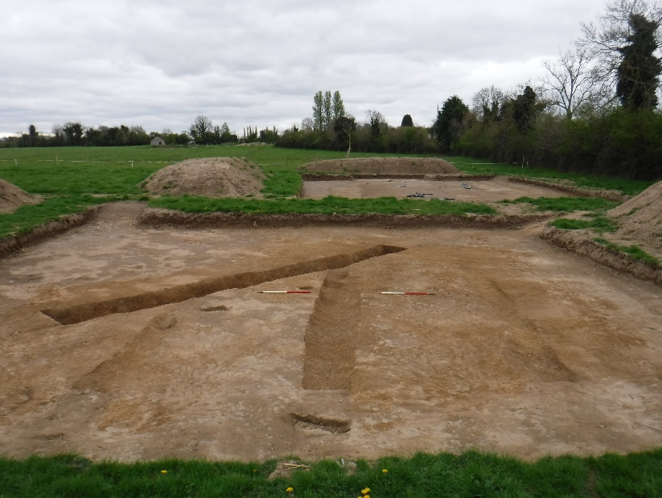  Cutting 3, post-excavation, facing south.

