Bulletin Information

Date Excavation was completed | 03/03/2017
Confirm excavation completion date | 03/03/2017
Year | 2017
County | Kildare
Author | David Bayley
Author’s Address | David Bayley, IAC Ltd, Unit G1 Network Enterprise Park, Kilcoole, Co. Wicklow
Site No | Automatically generated by website
Site Name | Ladytown 2
Site Type | Pit, drains, and furrows
ITM Coordinates | 685118/716408
Latitude & Longitude | Converted once submitted to website
Sites & Monuments Record No. | n/a
Excavation License No. | E004840
Description | Stage (iii) archaeological excavation at Ladytown 2 (Registration No.: E004840, Ministerial Direction No.: A072), was carried out in advance of the M7 Naas–Newbridge Bypass Upgrade and the M7 Osberstown Interchange and R407 Sallins Bypass Scheme, Co. Kildare. It was discovered during Stage (i) archaeological testing undertaken by Irish Archaeological Consultancy (IAC) Ltd and was further assessed during the Stage (ii) Pre-Excavation Services.  Ladytown 2 consisted of one pit and later agricultural features (six furrows and two drains).
Image | 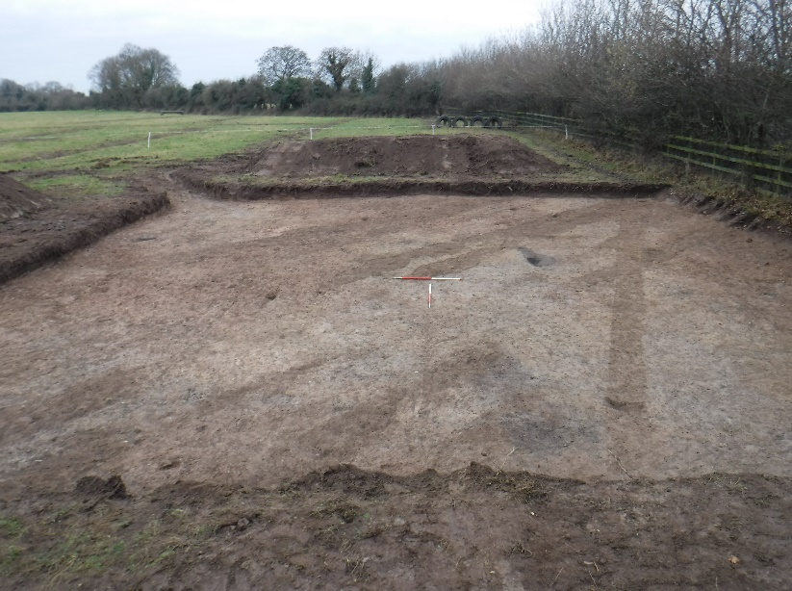  Ladytown 2, pre-ex, facing southwest.

