Bulletin Information

Date Excavation was completed | 22/02/2017
Confirm excavation completion date | 22/02/2017
Year | 2017
County | Kildare
Author | David Bayley
Author’s Address | David Bayley, IAC Ltd, Unit G1 Network Enterprise Park, Kilcoole, Co. Wicklow
Site No | Automatically generated by website
Site Name | Ladytown 1
Site Type | Pits and Furrows
ITM Coordinates | 685730/718315
Latitude & Longitude | Converted once submitted to website
Sites & Monuments Record No. | n/a
Excavation License No. | E004839
Description | Stage (iii) archaeological excavation at Ladytown 1 (Registration No.: E004839, Ministerial Direction No.: A072), was carried out in advance of the M7 Naas–Newbridge Bypass Upgrade and the M7 Osberstown Interchange and R407 Sallins Bypass Scheme, Co. Kildare. The site was discovered during Stage (i) archaeological testing undertaken by Irish Archaeological Consultancy (IAC) Ltd and it was further assessed during Stage (ii) Pre-Excavation Services.  Ladytown 1 consisted of a single pit with no other associated features. A number of agricultural features (six furrows and one field boundary) crossed the site also which are most likely relatively modern in date.
Image | 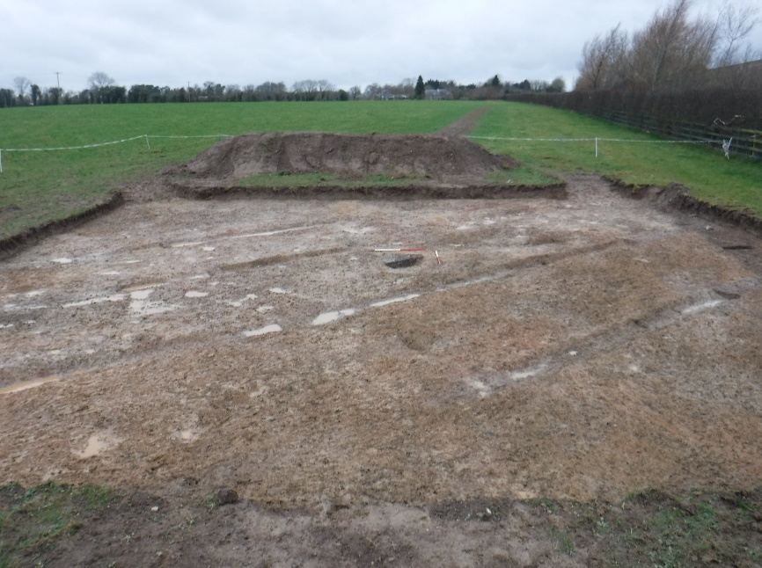  Ladytown 1, during excavation, facing west.

