Bulletin Information

Date Excavation was completed | 10/04/2017
Confirm excavation completion date | 10/04/2017
Year | 2017
County | Kildare
Author | David Bayley
Author’s Address | David Bayley, IAC Ltd, Unit G1 Network Enterprise Park, Kilcoole, Co. Wicklow
Site No | Automatically generated by website
Site Name | Newhall 2
Site Type | Burnt mound and pits
ITM Coordinates | 686202/718300
Latitude & Longitude | Converted once submitted to website
Sites & Monuments Record No. | n/a
Excavation License No. | E004838
Description | Stage (iii) archaeological excavation at Newhall 2 (Registration No.: E004838, Ministerial Direction No.: A072), was carried out in advance of the M7 Naas–Newbridge Bypass Upgrade and the M7 Osberstown Interchange and R407 Sallins Bypass Scheme, Co. Kildare. The site was discovered during Stage (i) archaeological testing and was further assessed during Stage (ii) Pre-Excavation Services both undertaken by Irish Archaeological Consultancy (IAC) Ltd.  Newhall 2 consisted of a largely ploughed-out burnt mound. The burnt mound was defined by three troughs, stone platforms, pits and a posthole which were associated with a deposit of burnt mound material.
Image | 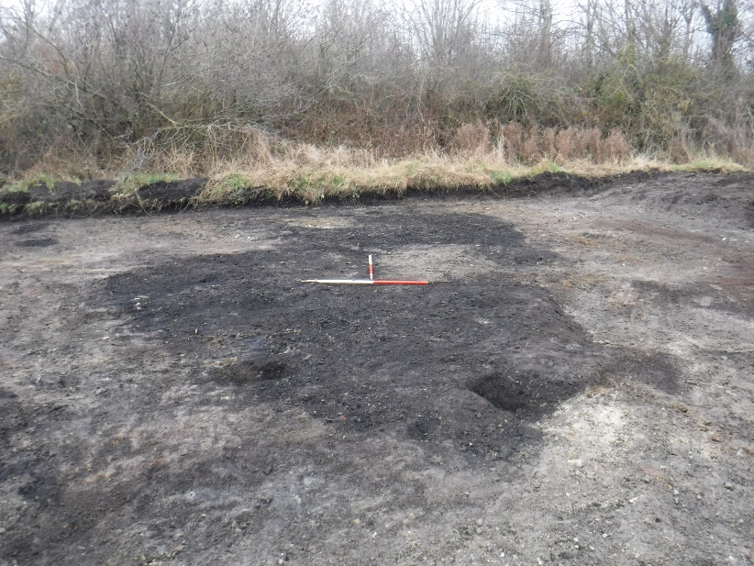  Burnt mound deposits, pre-ex, facing north.

