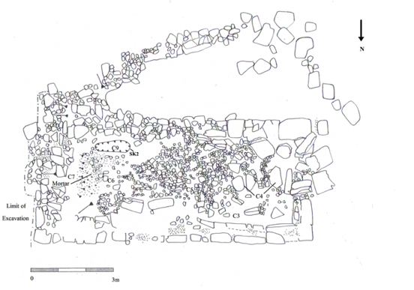
Post excavation plan of oratory and area to S.

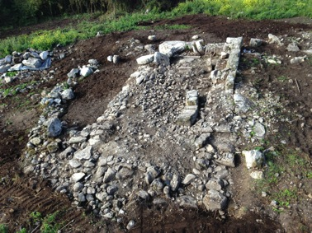
View of oratory after excavation. Taken from the E.

